

**RAPHA EXAMINATIONS BOARD**

e-mail: [raphaexaminationsboard@gmail.com](mailto:raphaexaminationsboard@gmail.com)

contacts: 0778710993/0740540111

**PRIMARY FIVE EXAMINATIONS 2024 (SET 3)**

**SCIENCE**

**Time allowed: 2 hours 15 minutes**

**Pupil’s name:**

**Signature: Date**

**School name:**

**District:**

**READ THE FOLLOWING INSTRUCTIONS CAREFULLY:**

1. This paper has two sections **A** and **B**
2. All the working in both sections **A** and **B** should be shown in the spaces provided
3. All working must be done using blue or black ball point pen or fountain pen.

Diagrams **MUST** be drawn in pencil

1. Unnecessary changes of work may lead to loss of marks
2. Any handwriting that cannot be easily read may lead to loss of marks
3. Do not fill in anything indicated for *examiners use only* and those inside the paper

**For examiner’s use only**

|  |  |  |
| --- | --- | --- |
| **SECTION** | **MARKS** | **INITIALS** |
| **SECTION A** |  |  |
| **SECTION B** |  |  |
| **TOTAL** |  |  |

## Section A (40 Marks)

1. Name the sense body organ for **sight**.
2. How do flowering plants reproduce in the environment?
3. Write any **one** product got from bees.
4. Of what importance is a **broom** at school?
5. Give any **one** reason for mulching the gardens.
6. Why is it a good habit **to wash hands with clean water and soap after visiting a latrine**?
7. Mention any **one** social insect found in the environment.
8. Name the habitat for **domestic rabbits**.
9. Why are school children advised to **bathe regularly**?
10. Name the best food for young babies.
11. How are **houseflies** able to carry germs from one place to another?
12. **Apart from bacteria**, mention any other **one** type of germs.

1. State any **one** common accident at school.
2. Name the larva stage for a cockroach.

## Of what importance is the garden tool shown below to a crop farmer?



1. **As a P.5 child**, why do you think it is a good habit to drain stagnant water?
2. Name the deficiency disease prevented by eating **cassava, irish potatoes, sweet potatoes and rice at home**.
3. How do **tape worms** enter into our bodies?
4. State any **one** cause of soil erosion in the compound.
5. State any **one** type of a fracture.
6. Of what importance are **roots** to plants?
7. Name the skin disease caused by **itch mites**.
8. Why are school children advised to cut their finger nails short?
9. State any **one** type of germination.
10. Name the main source of light and heat in the environment.
11. Write any **one** type of teeth.
12. Why are petals of some flowers brightly coloured?

**P T O**

1. Give any **one** reason for giving First Aid.
2. Name the childhood immunisable disease spread by cockroaches.
3. **Identify the property of air shown below.**

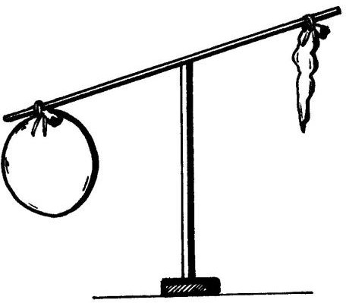

**Empty balloon**

**Balloon filled with air**

1. Name the type of soil good for making ceramics.
2. Of what importance are **feelers** to a cockroach?
3. Give the meaning of the term **personal hygiene**.
4. How can the human skin help to prevent rickets as a deficiency disease?
5. State any **one** element of a clean home.
6. Why do people fill fire extinguishers with carbondioxide gas not oxygen?
7. Give any **one** way of caring for garden tools at home.
8. How is **humus** formed in the environment?
9. Write any **one** product got from animal skins and hides.
10. Name the germ that causes cholera to man.

## Section B (60 Marks)

1. (a) Mention any **two** solitary insects found in the environment.

(i) (ii)

* 1. Name the insects that pollinate flowers at night.

(i) (ii)

1. (a) Write any **one** plant system.
   1. Which plant develops or grows into a branch?
   2. Mention any **two** examples of plants that bear flowers in the environment.

(i) (ii)

1. (a) Name the type of germination **where the cotyledons remain below the ground.**
   1. Mention any **two** examples of seeds that undergo above type of germination. (i) (ii)
   2. Name the part of the maize grain that provides food to the growing embryo.
2. (a) Which type of fracture **can Nakato get when she jumps down from the tall table**?
   1. Name the type of injury caused by dry heat.
   2. Write any **two** items kept in a First Aid box.

(i) (ii)

1. (a) Mention any **two** examples of flightless birds found in the environment.

(i) (ii)

* 1. State any **two** products got from domestic birds.

(i) (ii)

## Study the diagram below and use it to answer questions that follow.

**P T O**

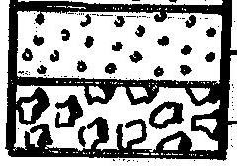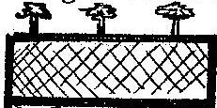

**A**

**Sub layer Gravel**

1. Name the part **marked A**.
2. What does the above illustration show about soil?
3. Name the layer suitable for crop growth.
4. In one sentence, explain what makes the layer mentioned above to be suitable for crop growth.
5. (a) Give the meaning of the term **dehydration**.
   1. State any **two** causes of dehydration.

(i)

(ii)

* 1. Why is dehydrated person adviced to take **oral rehydration solution (ORS)**?

1. (a) Mention any **two** examples of disease vectors.

(i) (ii)

* 1. State any **two** ways of controlling vectors at home.

(i)

(ii)

1. (a) Write any **one** type of leaf of venation.
   1. Mention any **two** examples of plants with the type of leaf venation mentioned above.

(i) (ii)

1. (a) Mention any **two** elements of weather.

(i) (ii)

* 1. Name the element of weather used for winnowing harvested crops at home.
  2. Of what importance is the **wind vane** in the weather station?

1. (a) Mention the main **two** groups of living things found in the environment.

(i) (ii)

* 1. State any **two** characteristics of living things.

(i)

(ii)

## (a) Name the deficiency disease prevented by eating the following sources of food.

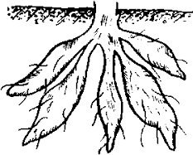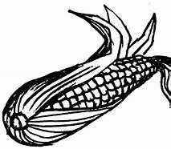

* 1. Apart from the above-mentioned disease, mention any **two** deficiency diseases.

(i) (ii)

* 1. Write **3Gs** in full as the main classes of food.

(i) (ii) (iii)

1. (a) What do we call **the covering of top soil with dry plant materials**?
   1. Mention any **two** examples of dry plant materials used for mulching the gardens.

(i) (ii)

* 1. Give the main reason for mulching the gardens with dry plant materials.

1. (a) Give the meaning of the term **domestic animals**.

**Animal**

1. **snake**
2. **monkey**
3. **dog**
4. **caterpillar**

**Movement**

**wriggles runs slithers**

**climbs**

1. **snake**
2. **monkey**
3. **dog**
4. **caterpillar**

* 1. Name any **two** domestic animas used as pets.

(i) (ii)

* 1. State any **one** way of caring for domestic animals at home.

1. **Match the following animals to their mode of movement.**